United International University
CSE 1116 - OOP Lab
Coding Assignment
Total Marks : 15
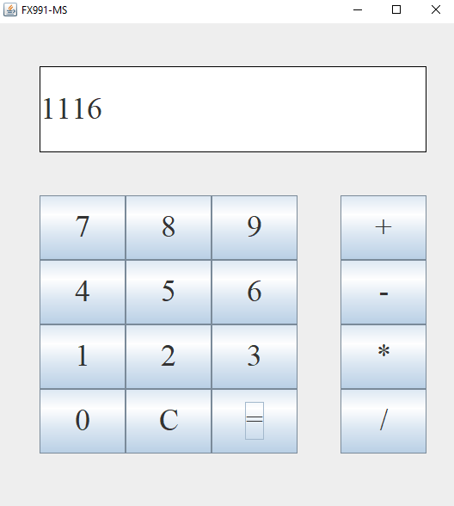
Q: Create a Calculator GUI using Java Swing. The Calculator will have the following functionalities:
i) The Calculator will have a number pad with numbers from 0 to 9
ii) The Calculator will have a Clear button (C) and an Equals button (=)
iii) The Calculator will have 4 operator buttons: Plus (+), Minus (-), Multiply (*), Divide(/)
iv) The Calculator will have a Display where the results will be shown
v) You have to perform the operations on only 2 numbers. You can display the whole operation on the screen, or you can show the results on the screen, but the operations have to be done correctly. The numbers must be shown on the screen when they are pressed. Only handle integer operations (division should also be integer division)
vi) The clear button clears the entire screen, and you have to start the operations again.
vii) The result of the operation will be shown only when the Equal button is pressed.
viii) You will have to handle the Divide by Zero error in whichever way you like
ix) Take care of the edge cases that might occur. For example: After pressing one operator, you cannot press another operator. After pressing an operator, you cannot press equal. Pressing a number when a result is on the screen should not append the number to the result, it either should set the number pressed as the new number, or do nothing at all.
x) You have complete implementation liberty. Your calculator should be working like a real-life calculator.
DO NOT COPY THE ASSIGNMENT. IF FOUND YOU WILL BE PENALIZED IN VIVA

